





INITIAL
ASSESSMENT
REPORT

DATE: 24th May 2024
Grievance

VERSION: 1.1

Document History
Document version | Remarks | Submitted  By | Submission  Date | Approved BY | Approval  Date
1.0 | First Draft | k&S Digiprotect | 24th May 2024
1.1 | Second Draft | K&S Digiprotect | 28th May 2024

K&S Digiprotect Services Pvt. Ltd.
Date of Discussion: Date of Release:
Version: 1.0
Date of Release: 15th April 2024

Table of Contents
Introduction 4
Objectives 4
General Information 5
SPOC Information 5
Department Hierarchy* 6
Key Processes 7
Data Flow Diagram (DFD) 9
Data Mapping and Inventory 10
Recommendations 11
Conclusion 11
Appendices 12
Appendix A 12

Introduction
The Grievance department of India Shelter ensures a fair and impartial channel for addressing customer dissatisfaction. They listen to concerns and strive to find solutions that leave everyone involved feeling heard and respected. This vital service promotes a positive and productive work environment.
This report encapsulates critical insights for As-Is study, derived from the initial interview conducted with the Grievance Department of India Shelter Finance Corporation Limited (ISFC) for the implementation of ISO/IEC 27001:2022 and compliance with the Digital Personal Data Protection Act (DPDPA).
The overarching objectives of this interview were dual fold: first, to gain an understanding of the departmental structure, and second, to delve into the core operational processes of the Grievance Department. Additionally, the interview aimed to assess the existing information security practices, focusing on evaluating adherence to DPDPA requirements and the readiness for ISO/IEC 27001:2022 implementation.
By delving into the details of the department's organizational setup, operational workflows, and data handling procedures, this report aims to identify both the strengths and areas of improvement in information security management and DPDPA compliance within the department.

Objectives
- Understand the departmental hierarchy and reporting structure
- Learn the existing processes of ISFC’s Grievance Department
- Mapping of existing processes with documented processes
- Offer recommendations to optimize the existing processes

General Information
Organization Name | India Shelter Finance Corporation Limited
Department Name | Grievance Department
Date of the Assessment | 24th April 2024
Location | 3rd Floor, India Shelter HQ, Gurugram
Meeting Duration | 30 minutes
Attendees (ISFC) | Rohit Singh, Sunil Kumar Sharma
Attendees (Digiprotect) | Lalit Mohan Joshi, Adhita Razdan

SPOC Information
Project SPOC: Dheeraj Yadav
Contact Information:
Email ID: dheeraj.yadav@indiashelter.in

Project Coordinator: Sunil Kumar Sharma
Contact Information:
Email ID: sunil.sharma2@indiashelter.in

Department SPOC: Rohit Singh
Contact Information:
Email ID: rohit.singh@indiashelter.in

Department Hierarchy*

* As informed during the meeting

Key Processes
S. No | Key Activities | Observations and Asks | Remarks
 | Customer communication  - Communication channels including mobile messaging platform (WhatsApp), electronic mail (email), and calls will serve as data sources for grievance redressal.  - Letters are also Received by the grievance team.  - Customer Grievances are divided into:  - Query – Resolved immediately on call  - Request  - Complaint.  - Customer Care has view rights of customer data and edit rights for cases (query, request, and complaint) created.  - Grievance department also receives queries from the below portals:  - NCH- National consumer helpline.  - GRIDS- Global resource information database  - CPGRAMS- Centralized public grievance redress and monitoring system.  - Grievances from these portals are manually recorded in ISFC’s systems.  - Physical Letters are sent to customers on the official letter head of ISFC signed by CGRO. A copy of the same is uploaded on the grievance portals for record keeping. | - No involvement of branches to send or draft the response of grievance. However, sometimes branches have discussions/ interactions with customer(s) when grievance team inform them about the concern.  - Access of external portals is with Rohit Singh and compliance team. | - No SOP for grievance redressal.  - All legacy data is still available with the team. No data retention period defined.
 | Customer Verification  - All calls are captured via IVR solution which is integrated with Salesforce.  - Customer Verification is done using Physical address, phone number, or registered emails.  - Reverse confirmation of receipts of physical letters is taken through Courier. | NA

Data Flow Diagram (DFD)
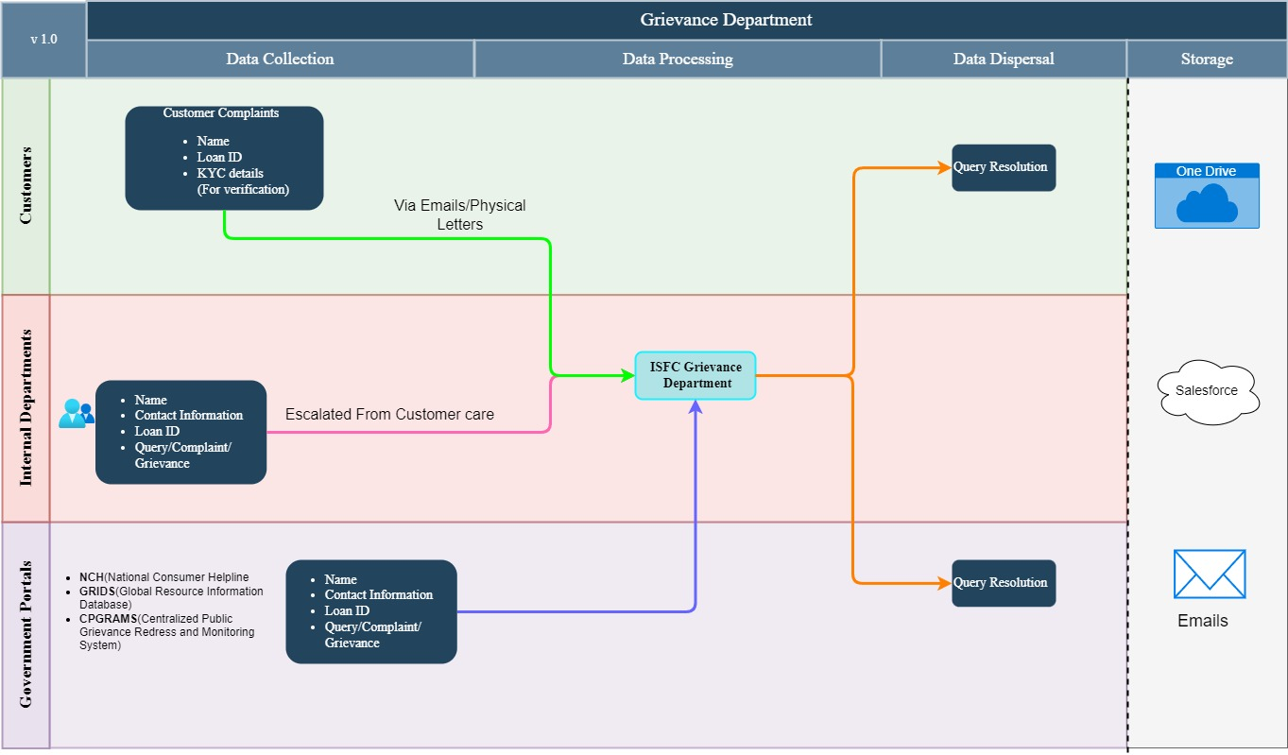

Data Mapping and Inventory
S. No | Data Category | Description | Purpose | Data Owner | Storage Location | Data Classification* | Retention Period | Legal Basis
1. | Customer Queries (Tickets Generated) | Issues raised by customers are stored to be addressed | Resolution of Customer Queries | Grievance team | Salesforce | PII/ Sensitive data | Not defined | Consent
2. | Call Logs | Query, Request and Complaint calls by customers are recorded | Quality Assurance and Training,  Dispute Resolution | Customer care team | Salesforce | PII/ Sensitive data | Not defined | Consent
3. | Confirmation receipt | Reverse confirmation of Customer queries to resolve issues | Efficient Customer Service and  Fraud Prevention | Grievance team | Email/  OneDrive | PII/Sensitive data | Not defined | Legitimate Interest
*Refer Appendix A

Recommendations
- Implement Standard Operating Procedures (SOPs) for Grievance Redressal:
- Develop and implement detailed SOPs for handling queries, requests, and complaints, to ensure consistency and efficiency throughout the process.

- Define Data Retention Policies:
- Establish and enforce data retention policies for grievance records and customer communication.

Conclusion
ISFC Ltd. has created a robust pipeline for resolving customer grievances. For establishing customer contact for queries, complaints and requests they have setup:
- Mobile messaging platforms like (WhatsApp)
- Dedicated Grievance inbox (Email)
- Helpline number for resolving queries immediately
- They also have access to consumer support portals like NCH, GRIDS and CPGRAMS.
They have also a customer identification protocols in order to streamline customer queries, complaints, and requests resolutions:
- IVR solutions for call recordings
- Customer verification is also done through Name, contact info, KYC, Load ID, Phone No. and Email verification for multifactor authentication and increasing security.
- They also accept physical Letter queries by post and have reverse confirmation services through post.

Appendices

Appendix A
Data Classification | Definition
Sensitive Data | Information that, if disclosed, altered, or destroyed without authorization, could cause significant harm to an individual, organization, or entity. This often includes financial records, medical information, and PII.
Restricted Data | Highly sensitive data tightly controlled due to legal, regulatory, or contractual requirements. Access is limited to authorized personnel, and any unauthorized disclosure may result in severe consequences.
Private Data | Information considered confidential and intended solely for specific individuals or groups within an organization. It requires protection from unauthorized access to maintain privacy and uphold confidentiality agreements.
Confidential Data | Privileged or proprietary information of an organization requiring protection from unauthorized access, disclosure, or alteration.
Public Data | Information that is freely available and accessible to the general public without restrictions or limitations. It does not contain sensitive or confidential information and can be openly accessed and used for various purposes such as research, analysis, and public interest initiatives.
PII (Personally Identifiable Information) | Data that can identify, contact, or locate an individual, either alone or in combination with other information. For example - names, addresses, official identifiers (Aadhar, Pan, DL, biometrics, etc).
Non-PII | Data that, while not personally identifiable, however may still require protection due to its sensitivity or confidentiality. This may include corporate financial information, proprietary research data, or internal communications.

-------------------------------------------End of report for Grievance------------------------------

